{Write Styler Requirements Specification}

*Prepared By:*

Kapil Patel & Hemant Gawande

P: 03 9099 2391 / 03 9099 2375

Mail: [kapil@23digital.com.au](mailto:kapil@23digital.com.au)

Mail: [hemant@23digital.com.au](mailto:hemant@23digital.com.au)

*Prepared For:*

Greg Thomas

P: 0400119002

Mail: [gregorythomas1@hotmail.com](mailto:gregorythomas1@hotmail.com)



Web Application Development for

Write Styler

**Document Version History**

|  |  |  |  |
| --- | --- | --- | --- |
| **Version** | **Date** | **Author** | **Description** |
| 1.0 | 05/03/2019 | Kapil Patel | Document initialisation |
| 1.1 | 19/03/2019 | Hemant Gawande | Internal review of the first draft |
| 2.0 | 18/04/2019 | Hemant Gawande | Internal review of the final draft post client’s feedback |
| 3.0 | 23/06/2021 | Hemant Gawande | Added more elaboration and design-based references, removed all phase 2 part as this has to be more focused on current development at hand.  1st & 5th July - Added comments from discussion as much as I can, please add discussed points comments for future reference. Also added comments from client for future reference. |

**Contact Link**

|  |  |  |  |
| --- | --- | --- | --- |
| **Contact** | **Position / Company** | **Project Role** | **Phone Number / Email** |
| Kapil Patel | 23Digital | Head of Production | [kapil@23digital.com.au](mailto:kapil@23digital.com.au) |
| Hemant Gawande | 23Digital | Project Manager | [hemant@23digital.com.au](mailto:hemant@23digital.com.au) |
| Gregory Thomas | Write Styler | Business owner | [gregorythomas1@hotmail.com](mailto:gregorythomas1@hotmail.com) |

Table of Contents

1. Introduction 5

Purpose 5

Scope 5

Definitions 6

References 6

2. Overall Description 7

Writestyler Requirements list 7

User Characteristics & User Stories 8

Administrator 8

Schools 8

Teachers 9

Students 10

User Stories 11

Flow Charts 13

School Admin Flow 13

Teachers Flow 14

Student Flow 15

Pricing Structure 16

School Admin Account level discounts - Bulk Order Discount 17

Features: 17

3. Functional requirements 20

RQ001 User Types 20

RQ002 Login 20

RQ003 Registration 21

RQ004 Payment Method 22

RQ005 Forgot Password 22

RQ006 Grades 22

RQ007 Levels 23

RQ008 Genres 23

RQ009 My Dashboard 24

RQ010 My Portfolio 28

RQ0011 My Classes 28

RQ0012 Manage Students 28

RQ0013 Teacher Feedbacks 29

RQ0014 Teacher Assessments/and assignments 29

RQ0015 Games 29

RQ0016 Hall of Fame | Graphic Novels | Teacher & Student Versions Worksheets 30

RQ0017 My Notebook 30

RQ0018 Assessments 30

RQ0019 Contact Us 31

RQ0020 FAQ 31

RQ0021 CkEditor 31

4. Design Constraints 33

Brand Guidelines 33

Mobile Friendly Design 33

5. Production Process 34

Requirement Definition Meeting 34

Design 34

Development 34

QA Testing / UAT 34

Deployment and Acceptance 35

6. Hosting Requirements 36

7. Additional Comments 37

List of Figures

Figure 1: School Admin's Writestyler System Flow 13

Figure 2: Teacher's Writestyler System Flow 14

Figure 3: Student's Writestyler System Flow 15

# 1. Introduction

The aim of this document is to gather and analyse and give an in-depth insight of the web portal by defining the problem statement in detail.

It is important to note that this document forms the foundation on which all development will take place. As such, it’s critical that any inaccuracies or omitted functionality be raised prior to agreeing the scope of the work.

## Purpose

The purpose of the document is to collect and analyse all assorted ideas that have come up to define the system, its requirements with respect to consumers. Also, we shall predict and sort out how we hope this product will be used to gain a better understanding of the project, outline concepts that may be developed later, and document ideas that are being considered, but may be discarded as the product develops.

In short, the purpose of this SRS document is to provide a detailed overview of the product, its parameters, and goals. This document describes the project's target audience and its user interface, and software requirements. It defines how our client, team and audience see the product and its functionality. Nonetheless, it helps any designers and developers to assist in software delivery lifecycle (SDLC) processes.

## Scope

23 Digital is supplying the strategy, design, development, project management and deployment of the website. We will handle all creative and development requirements as part of this project. This essentially includes:

|  |  |
| --- | --- |
| * Concept development * Design Refinement * Front-end Development * Back-end Development | * Testing * Deployment * Hosting * Basic SEO |

23 Digital will use our copywriting services as a part of the project to reword or come up with better wording for the development of an online web application. Our price does not cover data entry. The client is also responsible for ensuring that copyright is obtained for the materials used in the website, which specifically includes contents, images and videos. 23 Digital will help you source the images.

## Definitions

|  |  |
| --- | --- |
| SRS | Software Requirements Specification |
| CMS | Content Management System |
| CRM | Customer Relationship Management |
| CSV | Comma delimited data file |
| CTA | Call to Action |
| DB | Database |
| FTP | File Transfer Protocol |
| SEO | Search Engine Optimisation |
| TBC | To be confirmed |
| TBD | To be determined |
| WYSIWYG | “What You See Is What You Get” HTML rich text editor |
| LHS | Left Hand Side |
| RHS | Right Hand Side |
| N/R | Not Required |
| N/A | Not Applicable |

## References

**Client Reference Wireframes:**

<https://gregorythomas10.wixsite.com/writestylerprototype>

**Features API references:**

Writing Stylus Integration APIs:

1. <https://sketch.io>
2. <https://www.autodraw.com/>
3. <https://www.tiny.cloud/>
4. <https://ckeditor.com/>

# 2. Overall Description

## Writestyler Requirements list

The following lists all the functions required by the website.

RQ# - Requirement number

RQ001 User Types

RQ002 Login

RQ003 Registration

RQ004 Forgot Password

RQ005 Grades

RQ006 Levels (Easy, Intermediate, Hard)

RQ007 Types/Styles (referred to hereafter as ‘genres’)

RQ008 My Dashboard

RQ009 My Portfolio

RQ0010 My Classes

RQ0011 Manage Students

RQ0012 Teacher Comments

RQ0013 Teacher Assessments/and assignments

RQ0015 Share Functionality

RQ0016 Convert to PDF

RQ0017 Link Account

RQ0018 Writing Games

RQ0019 Writing Examples

RQ0020 My Notebook

RQ0021 Projects / Assessments

RQ0022 Project / Assessment details

RQ0023 Contact Us

RQ0024 FAQ

RQ0025 Admin Portal

## User Characteristics & User Stories

This section explains top level user characteristics, which are covered in detail under Functional Requirements.

Website is mainly divided into three primary users as below:

1. Administrator [website admin]
2. Students
3. Teachers
4. Schools

Note: Everybody else is a user browsing the website who does not have a standard defined flow and cannot access the backend thus he is not a part of user type.

### Administrator

The administrator plays an important role in populating and managing the website. Owner of the Writestyler will have this level of access and create other website admins to manage the website.

The high-level functions of an administrator are:

1. Content management for the website which includes task such as,
   1. Update CMS media (Logo/Banner/Video etc.)
   2. Add / Update CMS pages
   3. Add / Update Website menu
   4. Add / Update Writing Genre’s
   5. Add/Update template for each genre.
   6. Add/ Update writing games (Writestyler is going to update the games via 3rd party not a part of current project scope)
   7. Add grades / levels according to school’s requirements
   8. Share functionality
2. User Management which includes task such as,
   1. Add/update/delete user such as student /teachers
   2. Review the new account request and approve the accounts

### Schools

Administrator will be creating accounts for schools which will have access to different features that will allow them to add teachers and students.

The high-level functions of a school admin are:

1. School accounts recommended if business is targeting users in mass, as having one school onboard would bring 100s of students each year after year.
2. School admin will have to request for an account which will have to be reviewed by admin and approved based on the number of users they are after which they can add within the account. They can signup from the pricing page link at the bottom.
3. Once school user account is created, they would have access to multiple features as listed below using which they can grant access to teachers and students.
4. Content management for the website which includes task such as,
   1. Adding / Updating Writing Genre’s for school
   2. Adding template for each genre.
5. User Management which includes task such as,
   1. Add / update grade/levels for students and assign teachers to respective grade/level accesses.
   2. Add/update Classes and assign teachers to different classes
   3. Add/update access for teachers to templates section
   4. Add / update access for students to various templates
   5. Add / update access to games for various levels and grades
   6. Review the new account request and approve the accounts for teachers/students
6. Reports:
   1. Ability to have report of individual student, displaying their overall score and breakdown for assessment.

### Teachers

Teachers can be created in two ways,

* Teachers will have ability to create accounts at individual level as well and have ability to invite students to access the system.
* School admin can also add teachers to the system from their dashboard.

The high-level functions of a teachers are:

1. Content management for the website which includes task such as,
   1. Add / Update Writing Genre’s for their students
   2. Add/Update template for each genre.
   3. Create new writing samples
   4. Create new assessments and assign to classes
2. User Management which includes task such as,
   1. Add / update classes and add students to different classes
   2. Import students using CSV
3. Assessment Management which includes task such as,
   1. Mark Students Writings and add comments
   2. Review Students planners and add comments
   3. Create / update Planners templates which can be used by students as it is
   4. Add / update writing examples / templates and ability to assign to different grades
   5. Create Assignments for students that are to be assessed

### Students

Student can create own account and use the system or will be added to system by Teacher / School.

The high-level functions of a student are:

1. Dashboard which includes,
   1. Add Planners / writings
   2. Review teachers’ comments / assessments
   3. View parents’ comments
   4. Play writing games
   5. My Notebook

## User Stories

|  |  |  |  |
| --- | --- | --- | --- |
| **Functional Area** | **As a / the…(Role)** | **I want…[Feature]** | **So that…[Benefit]** |
| Admin Functionality | Admin | Update Logo, Content, Media, Menu Structure etc. | They are Up-to-date with the latest branding |
| Content Management | Admin | Add/ Update writing Genre, templates, writing games, classes | It is updated for all the students/teachers/parents to use |
| User Management | Admin | Add / update schools, teachers, students and parents | They can access the system |
| Share function | Admin | Share writing/planners and games results (links) to any user | I can easily communicate with Writestyler users and not just through email but through Writestyler ‘syncing’ and system notifications (Phase 2) |
| Content management | School | Add/ Update templates, classes, grades/levels | It is updated for all the students/teachers/parents to use |
| User Management | School | Add/ update/Approve users such as Teachers, students. Parents | Users can access the system |
| Share function | School | School Admins should be able to share writing/planners/game results with all users connected to their school | School admins can lead their school direction. E.g. a school may want a year level to only be working on a certain genre at a time. (Phase 2) |
| Content Management | Teacher | Add new templates for different grades, add new classes | For students to use the templates and add students to different classes |
| User Management | Teacher | Add / Invite Students, Parents | Users can access the system |
| Assignment Management | Teacher | Mark assignments, add comments for parents/student on their work. | Students can improve on the essays and parents are aware of the progress made by their kid(s). |
| Curriculum Assess | Teacher | Directly assess writing against Australian Curriculum standards for Writing | Teachers can grade their students work and then produce student and class reports from this feature.  e.g.: <https://gregorythomas10.wixsite.com/writestylerprototype/copy-of-comment-assess-recount-write> |
| Share function | Teacher | Teachers should be able to share writing/planners/game results with any users connected under the same school, this includes students and teachers, parents & other users that are for example – all apart of Lyndhurst Primary school | So that schools can communicate as one connected entity |
| Access the system | Student | To access Writestyler | I can use Writestyler for accessing its feature |
| Access Writestyler | Student | Add/Update Planners | To plan my assignment work |
| View Example writings | Student | Review sample writing | To use the inputs in my writing |
| Improve Writing and complete assessments | Student | Write essays, narratives, essays | To submit and improve writing skills |
| Play Writing Games | Student | Play writing games available for my account | Use them to play and learn |
| Review Teacher feedback | Student | Review feedback from my teacher | So that I can improve my writing skills |

## Flow Charts

### School Admin Flow

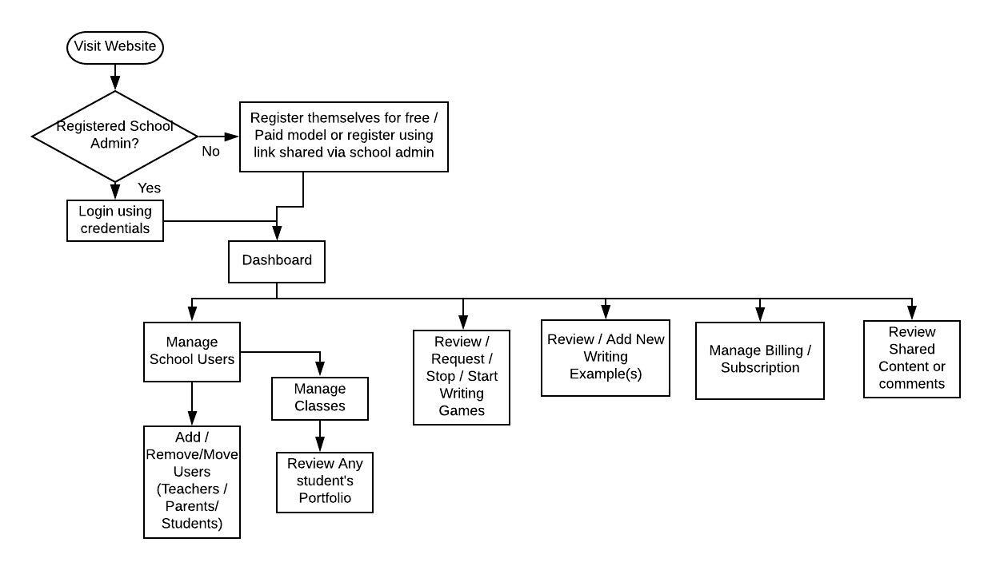

Figure : School Admin's Writestyler System Flow

Note:

* School admin will be creating accounts for schools which will have access to different features that will allow them to add teachers and students.
* Teachers will have ability to create accounts at individual level as well and have ability to add students to the writestyler system.

### Teachers Flow

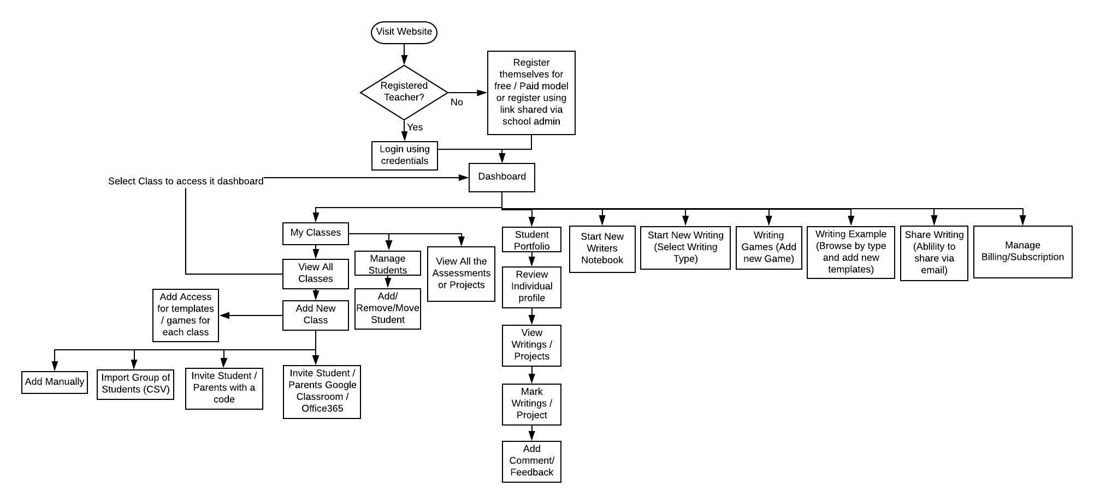

Figure : Teacher's Writestyler System Flow

### Student Flow

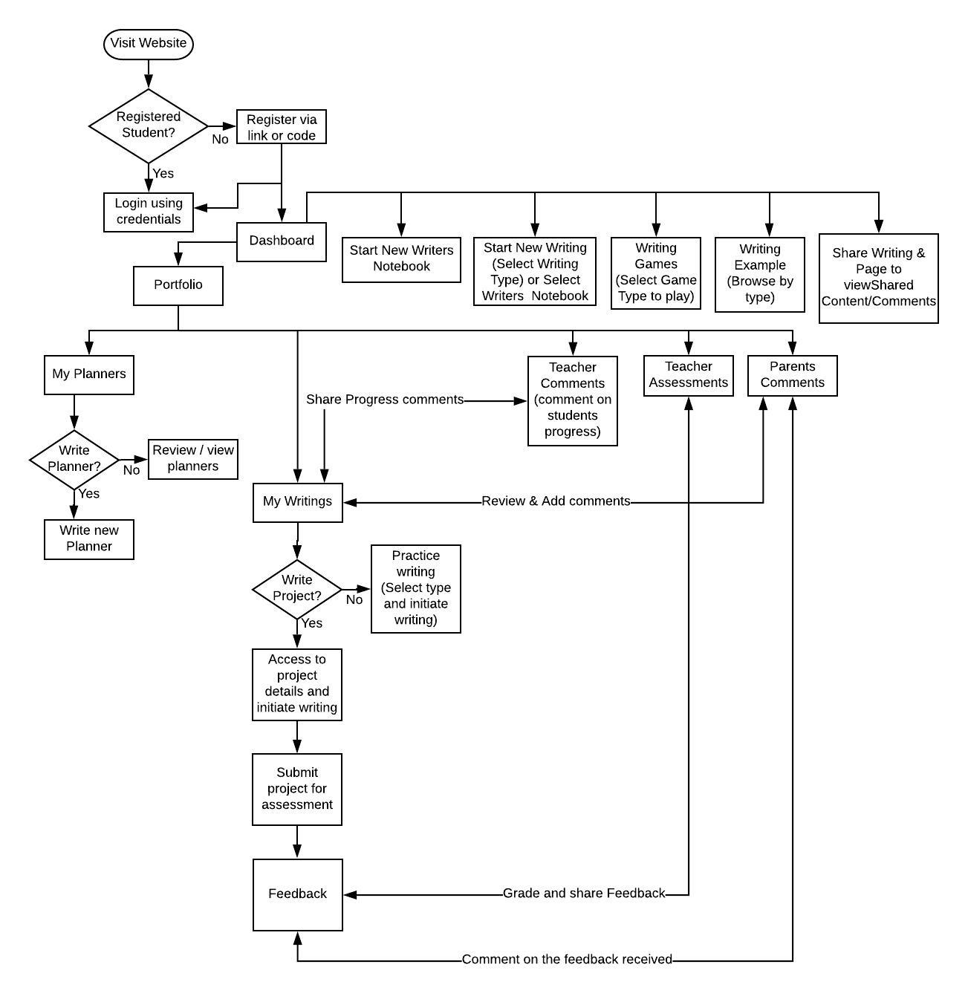

Figure : Student's Writestyler System Flow

## Pricing Structure

|  |  |  |
| --- | --- | --- |
| **Student / Teachers** | **Student / Teacher** | **Student / Teacher** |
| **FREE** | **$3.99 / yearly**  **per user** | **$8.99 / yearly**  **per user** |
| ***Students:***  Free… Forever. Made for students, teachers or anyone who wants to write with style.   * Writing Genres, Planners and instructional Videos * Selected Writing Games * Maximum of 5 Writing creations can be held in your Portfolio at any one time   ***Teachers:***  Writestyler is made by teachers, for teachers.   * Writing Genres, Planners and instructional Videos * Selected Writing Games * Maximum of 5 Writing creations can be held in your Portfolio at any one time * Create up to 35 Free student accounts * View all students Writing and Planners * Manage classes and student Portfolio’s   Create Free Account  See plan details | ***Students:***  Made for the productive writer with unlimited access to Writing content and Games   * Writing Genres, Planners and instructional Videos * All Writing Games * Unlimited amount of Writing creation * Unlimited Portfolio space   ***Teachers:***  Made for the busy teacher (AKA every teacher) with unlimited access to Writing content, Games & teacher Assessment (Australian Curriculum)   * Writing Genres, Planners and instructional Videos * All Writing Games * Unlimited amount of Writing creation * Unlimited Portfolio space * Create up to 70 Free student accounts* * Create any volume of Unlimited student accounts * View all students Writing and Planners * Manage classes and student Portfolio’s * Assessment of student Writing against curriculum standards (Australian)   Get Unlimited Now  See plan details | ***Students:***  Made for the dynamic writer with limitless access to Writing content, Games and exclusive premium content   * Writing Genres, Planners and instructional Videos * All Writing Games * Unlimited amount of Writing creation * Unlimited Portfolio space * Writestyler Writing & Grammar Worksheets for all Writing Genres * Writestyler Graphic Novels for all Writing Genres * Download Writing Planners * Download Writestyler ‘Hall of Fame’ Writing examples   ***Teachers:***  Made for the teacher who wants access to everything we offer. Writing content, Games, teacher Assessment (Australian Curriculum) as well as access to exclusive premium content   * Writing Genres, Planners and instructional Videos * All Writing Games * Unlimited amount of Writing creation * Unlimited Portfolio space * Writestyler Writing & Grammar Worksheets for all Writing Genres * Writestyler Graphic Novels for all Writing Genres * Download Writing Planners * Download Writestyler ‘Hall of Fame’ Writing examples * Create up to 100 Free student accounts* * Create any volume of Premium student accounts * View all students Writing and Planners * Manage classes and student Portfolio’s * Assessment of student Writing against curriculum standards (Australian)   Get Premium Now  See plan details |

### School Admin Account level discounts - Bulk Order Discount

|  |  |  |
| --- | --- | --- |
| **Bulk Order Account Type** | **Users** | **Price** |
| **Unlimited** | 100-500 | 10% discount - $3.59 per user |
| 500-1000 | 15% discount - $3.39 per user |
| 1000 + | 25% discount - $2.99 per user |
| **Premium** | 100-500 | 10% discount - $8.09 per user |
| 500-1000 | 15% discount - $7.59 per user |
| 1000 + | 25% discount - $6.69 per user |

### Features:

|  |  |  |  |
| --- | --- | --- | --- |
| **Compare Plans** | **Free** | **Unlimited** | **Premium** |
| **STUDENTS** |  |  |  |
| **Writing Genres** | **Yes** | **Yes** | **Yes** |
| **Writing Planners** | **Yes** | **Yes** | **Yes** |
| **Writing instructional Videos** | **Yes** | **Yes** | **Yes** |
| **Writing creations** | **5 at any one time** | **Yes - Unlimited** | **Yes - Unlimited** |
| **Portfolio space** | **limited** | **Yes - Unlimited** | **Yes - Unlimited** |
| **Games** | **Selected Games** | **Yes - Unlimited** | **Yes - Unlimited** |
| **Writestyler Writing & Grammar Worksheets** | **X** | **X** | **Yes** |
| **Writestyler Graphic Novels** | **X** | **X** | **Yes** |
| **Download Writing Planners** | **X** | **X** | **Yes** |
| **‘Hall of Fame’ Writing Examples** | **X** | **X** | **Yes** |
| **TEACHERS** |  |  |  |
| **Writing Genres** | **Yes** | **Yes** | **Yes** |
| **Writing Planners** | **Yes** | **Yes** | **Yes** |
| **Writing instructional Videos** | **Yes** | **Yes** | **Yes** |
| **Writing creations** | **5 at any one time** | **Yes - Unlimited** | **Yes - Unlimited** |
| **Portfolio space** | **limited** | **Yes - Unlimited** | **Yes - Unlimited** |
| **Games** | **Selected Games** | **Yes - Unlimited** | **Yes - Unlimited** |
| **View & Manage Classes and Student Portfolios** | **Yes** | **Yes** | **Yes** |
| **Free Student accounts** | **35** | **70** | **100** |
| **Create Unlimited/Premium Student accounts** | **Any volume** | **Yes - Any volume** | **Yes - Any volume** |
| **Student Portfolio Space** | **limited** | **Yes - Unlimited** | **Yes - Unlimited** |
| **Assess student Writing (Australian Curriculum)** | **X** | **Yes** | **Yes** |
| **Writestyler Writing & Grammar Worksheets (Student and Teacher versions)** | **X** | **X** | **Yes** |
| **Writestyler Graphic Novels** | **X** | **X** | **Yes** |
| **Download Writing Planners** | **X** | **X** | **Yes** |
| **‘Hall of Fame’ Writing Examples** | **X** | **X** | **Yes** |

***Pricing Page designs:***

<http://graphicdesignersdirectory.com.au/Writerstyler/themehtml/Pricing.html>

**School Admin Account:**

<http://graphicdesignersdirectory.com.au/Writerstyler/themehtml/School-Account.html>

# 3. Functional requirements

This section covers each functional requirement in detail. It’s vital that each minute requirement has been covered under this section.

## RQ001 User Types

1. There will be following types of users in the system
   1. Students
   2. Teachers
   3. Schools
   4. Admin (access to only backend)

NOTE: Everybody else are users who visit the website and not registered website users but visited website for browsing and understanding its feature.

## RQ002 Login

1. Certain features of the website will be accessible only after user creates their account, and only CMS / content pages will be accessible without login (see notes on the games accessibility for non-account holders)
2. Users can login to the system through following methods:
   1. Username/Password (depending on how the school admin or teacher creates their students account, usernames do not have to be email addresses
3. Teachers can create an account and invite students to their classes to use the free features of Writestyler
4. Students can be invited by teachers or parents can register and login themselves to use the system to the system without the invitation.
5. Schools will be invited once their account is created by Writestyler Admin and they can invite teachers to access various features within Writestyler system.
6. Writestyler admin will have access to all the system functionality.

Design:

<http://graphicdesignersdirectory.com.au/Writerstyler/themehtml/Login.html>

## RQ003 Registration

1. Student/Teachers can create their own account.
2. They will have to fill out signup form with following fields:
   1. User type (Student or teacher)
   2. First Name *
   3. Last Name *
   4. Email *
   5. Date of Birth * (to gauge Age)
   6. School Name (list of schools to be populated into backend manually by Writestyler from https://asl.acara.edu.au/)
   7. Password *
   8. Confirm Password *
   9. Payment options
      1. Free

* Teacher will be able to add 35 students and they will have option to create classes and use certain games, writing etc. to be added to the classes accordingly. Writestyler will have option on games level to choose which games should be visible on Free student level accounts.
* Students added to system linked to teacher or school will be able to create up to 5 writings, games and notebooks and if they wish to create new, they will have to delete their old work or request teacher to purchase
  + 1. Unlimited
* Annual subscription option (Check Features Section for more details)
  + 1. Premium
* Annual subscription option (Check Features Section for more details)

1. School admin will be make an request from School account page which will be reviewed and approved by Writestyler admin and respective access will be provided.

<http://graphicdesignersdirectory.com.au/Writerstyler/themehtml/School-Account.html>

1. Individual accounts can be created as well by Parents and Teachers, and allow them add classes, kids to their account respectively.
2. Students can create independent account for any paid services they will have to request respective parents / teachers.
3. Under a school setting if a student is added to the system but not assigned to any class but wish to, can add themselves by entering their class’ unique code. Eg a code that adds them to ‘Year 9 English’ and by default also adds them to Lyndhurst Primary School, because the teacher who created their account (and the Year 9 English’ class), entered Lyndhurst Primary as their school. Every grade that is created within Writestyler has their own unique code.

## RQ004 Payment Method

Client to confirm the payment gateway they want implement, below are some of the options we recommend,

* Stripe

NOTE: Client will share details for stripe during development or towards the end so that we can review and implement the subscription payments accordingly.

## RQ005 Forgot Password

1. Any registered users will be able to use this feature to retrieve their password.
2. Password will not be sent through email in plain text but reset password link will be sent for security reasons.
3. Rest link will expire after 60 min to ensure that the link is not accessed concurrently.
4. If user clicks on forgot password multiple times, it will generate new link each time and old link will expire.

## RQ006 Grades

1. These will be used with writings and games
2. Example of levels:
   1. Year 1
   2. Year 2
   3. Year 3
   4. Etc.
3. These will be writestyler admin controlled where admin can add new but can’t modify or remove which are already in use.
4. Writesytler by default will have default school grades added but as and when there is any update that can be added to the system via admin. Teachers will be able to add/manage their own grades for their account.
5. Grades will allow schools/teachers to provide access to different writing samples and material to the student considering their level of knowledge.

## RQ007 Levels

1. These will be used with Assessments, Games and Writing Genres
2. Example of levels:
   1. Easy
   2. Intermediate
   3. Hard
3. These will be admin controlled where admin can add new but cannot modify or remove which are already in use. School Admin / Teachers will also be able to manage / assign levels of their students, via ‘manage students’ which will allow them to assign levels as per student’s capability.
4. Levels will allow to schools/teachers to provide students to access the sample and games access based on their learning. For example: Student with low level of understanding and finding it difficult to understand a concept will be given access to easy game level.
5. Whenever a teacher is creating classes the games, writings, planners will be assigned to the classes as per the grade selected by default. This will allow the teachers to get a default selected option as per the grade as per intermediate level which they can update it they want to.

## RQ008 Genres

1. These will be used with writing templates and Games
   1. **Types for writing / games templates**:
      1. Narratives
      2. Recount
      3. Persuasive
      4. Information Report
      5. Procedural
      6. Explanation
      7. Writers Notebook
      8. Free Styler
2. Genres will be admin controlled where admin can add new but can’t modify or remove which are already in use.
3. School / teacher will be able to add specific types for different grades to implement personalized learning experience.
4. The default types will be applied as per mentioned above and will be applied to all the students.
5. Whenever a teacher is creating classes the games, writings, planners will be assigned to the classes as per the grade selected. This will allow the teachers to get a default selected options which they can update it they want to.

## RQ009 My Dashboard

**Writestyler Admin / School**

Writestyler admin will have access options such as,

Design: <http://graphicdesignersdirectory.com.au/Writerstyler/themehtml/Dashboard.html>

1. Dashboard
   1. This will show,
      1. Total Users (Teacher & Students)
      2. Total Writings
      3. Total Games
      4. Total Assessments
      5. Total Revenue
   2. Bar Graph for Total users divided into free | unlimited | premium. Y Axis showing users and X axis showing month

(SELECT sum(no_of_users), s.name, MONTHNAME(usd.datetime_created) FROM `user_subscription_details` usd

LEFT JOIN subscriptions s ON s.id = usd.`subscription_id`

GROUP BY MONTHNAME(usd.datetime_created), s.name)

* 1. Line Graph for Revenue showing revenue on y axis and months in x axis.

SELECT sum(amount), MONTHNAME(usd.datetime_created) FROM `user_subscription_details` usd

GROUP BY MONTHNAME(usd.datetime_created)

* 1. Latest Subscription table which will show list of latest 10 users who have subscribed to Writestyler

1. Accounts
   1. This will show all the accounts in table with filters option on top to filter by type such as Teacher, Student & School
   2. Table will have action column with option such as edit, delete, login as user
   3. At top of the table, it will have option to create new account.
   4. NOTE: Account is more for system account users and separate section within setting will have option to create admin accounts to manage writestyler backend.
2. Writing
   1. This page will have sub sections as following,
      1. Styles – it will show all the styles (genres) in the system and have option to add new styles and templates for each styles
      2. Grades(Classes) – It will allow to add new grades in the system
      3. Level – show all the grades in the system also have option to add new levels
      4. Planners – Allow to add new templates of planners and also show all the existing planner templates
   2. Admin can also write a writing with option on the top of the table which will ask him options on which type of writing he wants to write (8 genres) and then take them to writing page which will look like below design,

<http://graphicdesignersdirectory.com.au/Writerstyler/themehtml/Recount.html>

1. Games
   1. Options to review all the games in system and add new games
   2. The page will show list of games in the system and have option at the top right corner to add new games
   3. Add new game will request to add zip file generated from game constructing site along with fields such as genre which the game is for, difficulty level of game, grades it is applicable for.
   4. Admin can have a featured game which will be visible on Teacher / Student’s dashboard. Only one game can be marked as featured game at one point of time.
2. Billing
   1. This will show list of all the subscription in the system with payments that are made and other information
3. Settings (top right corner next to name)
   1. Account requests
      1. School Admin will send bulk account request which admin can review and send them option to open an account and make payments for the subscriptions
      2. School admin can login to account and make payments for the requested accounts subscription
      3. Once they make payment then they can add teachers / student into the system. Teachers can be given access to add student and classes accordingly.
   2. Front end Website Menu Management
   3. Pages management such as home page banners, content
   4. Videos – Add /manage videos. Only one video can be assigned a flag of feature video and Getting started video which will be visible on teacher / student’s dashboard.
   5. Hall of Fame / Graphic Novels / Teacher student version worksheets – All PDFs which are added by school / teacher account for their respective accounts which will be visible to students (Premium account feature). Admin can review all the PDFs that are uploaded.
   6. Contact Enquiries

**School Admin will have similar options as Writestyler admin but with limited option to add new templates for level, grades etc which is more for Writestyler admin.**

*School admin will have option to login to teacher’s & student’s account in order to help support them accordingly*

**Teacher**

1. Dashboard

Design: http://graphicdesignersdirectory.com.au/Writerstyler/themehtml/Teacher.html

* 1. Can view 4 recent writings with option to write new writing.
  2. When the click on write new writing thy will get option to select from styles, levels and then then can start to write which will be a page like below,

<http://graphicdesignersdirectory.com.au/Writerstyler/themehtml/Recount.html>

* 1. Below the above section their will be section which will show Getting started video, Featured Video and Featured Game.
  2. On click of video it will open in pop-up and on click of game it will open game in new tab.

1. Teachers
   1. List of all the teachers if part of school with option to View / Add / Edit any teachers details for eligible teachers.
2. My Classes
   1. View / Add classes and option to add new students to different classes
   2. If they have exhausted the account of student they have they can purchase new which will take them to a screen where they have to select users they are after, account type and based on that payments will be updated.
   3. Within each class section teachers will have option to create assessment for complete class
3. Students
   1. List of all students with option to add / edit students. Teacher’s will have option to login to student’s account so that they can help them in case they are facing any difficulty.
   2. Teachers can view portfolio of students which will show all the writings of the students done so far, assessments done if any, planners written if any.
   3. Create assessment section will allow to create assessment for particular class or individual student this will ask teacher
      1. What assessment style(genere) they want to create
      2. Question for the assessment
      3. If they want to assign it to a class they can select class or if for an particular student they can select email of student accordingly
   4. View all assessment will show all the assessments done under that teacher with latest / non marked on top. Teacher can click on individual assessment and mark them with standards that are set as per Australian educations department.
4. Writing
   1. Ability to review all the writings done or start new writing
   2. Hall of Fame / Graphic Novels / Teacher student version worksheets– This will be all the example writings / graphic novels PDFs which are marked as best writing. Admin can add this onto the account of school or teacher. Teachers / School admin can also upload these which will only be visible for their accounts. (this feature is available for premium account only)
5. Games
   1. Options to review all the games in system and assign those to student games
6. Billing
   1. Review all the billing details/ invoices etc.
   2. Payment – Show the subscription payment etc. along with any payments they have to make payments to purchase new accounts.

**Student**

1. Dashboard

Design: http://graphicdesignersdirectory.com.au/Writerstyler/themehtml/Teacher.html

* 1. Can view 4 recent writings with option to write new writing.
  2. When the click on write new writing thy will get option to select from styles, levels and then then can start to write which will be a page like below,

<http://graphicdesignersdirectory.com.au/Writerstyler/themehtml/Recount.html>

* 1. Below the above section their will be section which will show Getting started video, Featured Video and Featured Game.
  2. On click of video it will open in pop-up and on click of game it will open game in new tab.

1. My Portfolio. Teachers need a ‘My Portfolio’ too. For both teachers and students, it can be placed under the ‘Writing’ drop-down Dashboard menu item. It will be show the below as you have written.
   1. Student writings which they can filter by styles (genres)
   2. Planners which are organized by genres
   3. My writer’s notebook
2. Games
   1. View / Play games and filter by genres to select respective games
3. Assessments
   1. List of all Assessments which are due or not done
   2. Students will have section to review all the past assessments and review its feedback accordingly

## RQ010 My Portfolio

This section is designed for students and teachers to review their own portfolio via the Writing Dashboard drop-down option. The section will have following functions,

1. Planners by Style (Genres)
2. Writing by Style (Genres)
3. Notebook

## RQ0011 My Classes

This section is designed for teachers/school admin where they can,

1. View all the classes in one view
2. Add new classes
3. Review all the student’s profile in different classes
4. Import students in bulk by using
   1. CSV Import
   2. Manual add students to classes via View All student page
   3. Google Classroom (Need to research) (phase 2)
   4. Office365 (Need to research) (phase 2)
5. Whenever a teacher is creating classes the games, writings, planners will be assigned to the classes as per the grade selected by default. This will allow the teachers to get a default selected option as per the grade as per intermediate level which they can update it they want to.

## RQ0012 Manage Students

This section is designed for teachers / school admin where they can,

1. Add / remove students individually or in bulk for a particular class by teacher / school admin.
2. Move all the students from one class to another

## RQ0013 Teacher Feedbacks

This section is part of student assessments or writing are reviewed by teacher and feedback is provided. Students can review the feedback they have received for the overall progress in respective classes.

## RQ0014 Teacher Assessments/and assignments

Assessment view is for teachers to view assessments for their classes which can be accessed from My Classes. (Assignments section under the dashboard).

This view will show all the assessment submitted by students for class. Teacher can view and mark assessment and share grades with comments to individual student based on their submission.

Assignment feedback or remarks can be seen by parents / teacher and students,

* Teacher will be able to grade/mark student works (against predetermined Australian Curriculum standards) and provide a brief feedback to it using the sketch section or keyboards
* Students can review the feedback / remarks for improvisations required in future work.

NOTE: Australian Curriculum Standards is an standard set by Australian education system to ensure the grades are marked as per those standards. This will be an PDF within Assessment section for teachers to follow accordingly. Can we make this more a checkbox system? Where teachers can see the list of standards and simply ‘check’ which ones they have done, then provide comment? See <https://gregorythomas10.wixsite.com/writestylerprototype/copy-of-comment-assess-recount-writ>

## RQ0015 Games

1. Writestyler admin will be able to add this writing games to the system which can be accessed by different schools / teachers to add to students’ profile.
2. Students can play games based on difficultly levels and grades they are assigned to. Students can choose for different types of games to improve the respective skills such as narratives, essays, resume etc.
3. Admin can add the game zip file and image of the game which will be visible on the front end.
4. Game list page will be boxes of games with filter option on the top to filter by styles (genres), levels and grades.

## RQ0016 Hall of Fame | Graphic Novels | Teacher & Student Versions Worksheets

1. As explained in prior sections, this will be mainly PDFs which are added by teacher and school admin for their account which can be visible to students under respective section on their account. Admin will be able to view all this and remove anything if it is inappropriate.
2. Writestyler admin will also be able to add new samples which can be used directly by various schools to be shared with students.

## RQ0017 My Notebook

1. Students can use this section to add notes or scribble any ideas.
2. They can use this section as a rough book were, they can write down notes for future reference.
3. This section can be viewed by parents/teachers for the students to whom they are directly managing.
4. This section will be like a diary and be like multiple pages with the latest one at the top.

## RQ0018 Assessments

1. Teachers will be able to add different writing assessments for students which will have deadlines and be graded by teachers post submission by students.
2. Assessments will be different from different classes and teachers can add projects for students for each class and have ability to define deadlines and submit marking for each project for that class.
3. Assessments will be mostly writing oriented and will test students’ skills in different writing areas.
4. Assessments will be writing assessment which student will have to complete and submit.
5. Teachers will review / mark writings and share the feedback which can be reviewed by student via the feedback section.
6. To mark assessment, Teachers will have to export the writing in PDF and add comments and upload the PDFs for student to review. (see above comment)

## RQ0019 Contact Us

1. This page will be mainly be a form were any user can enquiry about the product or raise any concern they faced while using the system.
2. Form will have basic fields like,
   * Name
   * Email
   * Phone (don’t need phone)
   * Country
   * State
   * Message
   * Invisible Captcha (to avoid spam enquiries)
3. This page will also list down the contact information such as,
   * Email
   * Phone no.
   * Fax
   * Address

## RQ0020 FAQ

1. This section will list down all the general queries asked by different profiles such as student / parents / teachers / schools and new users.
2. There will be an option for admin to add new questions, and answer for respective question plus organize them in required order.

## RQ0021 CkEditor

As per request from client CKEditor version 5 will be used.

<https://ckeditor.com/ckeditor-5/online-builder/>

Below image show all the features within CKEditor that are requested to be added.

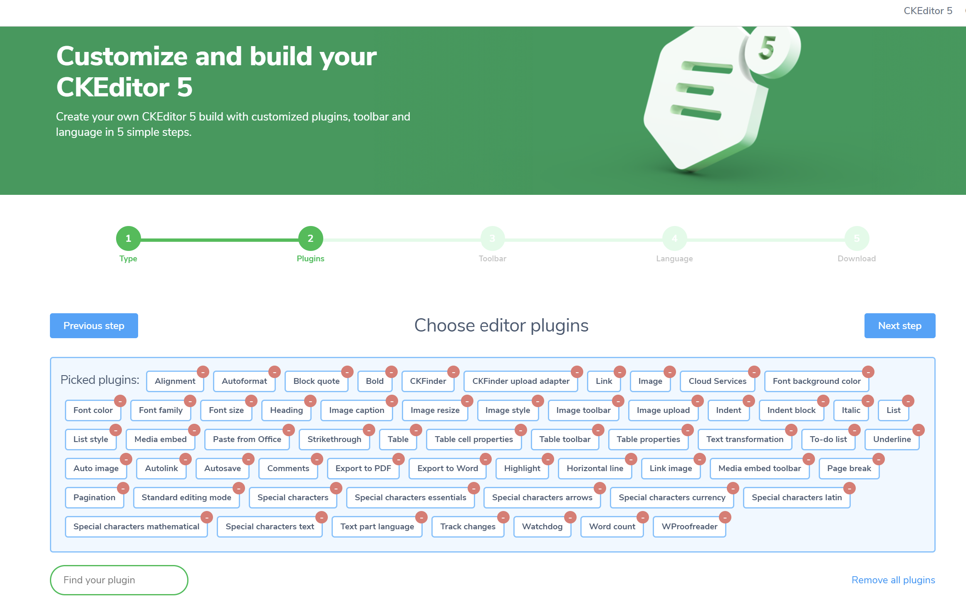

All paid features will be reviewed during development and anything and based on implementation option we will share inputs during development phase. Any new features requested during development or UAT will have to reviewed at the time and feasibility to include them will have to be finalised.

NOTE: As per our initial review CKeditor version 5 is an cloud based version and any inclusion of specific font styling has to be discussed with CKeditor support directly.

Further, CKEditor 5 also might not allow to have an option to add hand/stylus writing. We will have to provide an separate button on top of editor to achieve this. The review we had done was within CKeditor 4 which was a completely different version.

# 4. Design Constraints

## Brand Guidelines

Colour Combination: as per brand requirements, shared during design phase

Fonts: As per brand requirements, shared during design phase

***NOTE: Font styling within CKeditor 5 cannot be controlled via code level it is something controlled from CKEditor itself.***

## Mobile Friendly Design

Web application design would be created using Responsive Web Design (RWD) approach structure, which allows desktop webpages to be viewed in response to the size of the screen, or web browser one is viewing with.

# 5. Production Process

## Requirement Definition Meeting

This is second stage in which requirements are discussed with you. The deliverable of this process is system requirement specification document, which includes all the business and technical requirements. From this point, your project manager will use this document as the primary reference for the rest of the project. This stage has the following steps:

1. Requirements Analysis
2. Validation of the Scope and estimates against the contract and revisions made if necessary

Expected time frame to receive SRS document will be 12-14 Business Days depending on complexity of the project. Client to supply all content and images before design work commences.

## Design

This stage develops the graphic design of the known content and architecture, while applying the look-and-feel of your business visual identity. Using Photoshop, these visual concepts take the form of digital graphics and are not yet actual web code.

There are usually two designs to view — one for the home page, and one for the secondary (non-home) pages. These visual concepts will be modified with you until we reach an approved visual design as per the plan outlined in proposal. For all projects where a proposal does not specify otherwise, the client will be supplied with an initial layout, with 2 revisions, or a second layout if the first is unsatisfactory, with 2 revision cycles made to the second layout.

Expected Time frame: 20-25 Business Days (after providing logo and other required images). Design can be produced parallel to the SRS documentation depending on the nature of the project.

## Development

Development will begin with the integration of the approved graphic design via web coding practices into the Magento Community Edition system. We’ll also input up to 15 pages of your content. This involves making each web page, typesetting of content, optimization and placement of images, linking to PDFs and such.

Expected Time frame: 60-90 Business Days after signing off design and the SRS document.

## QA Testing / UAT

At this point, our Quality Assurance team will attend to the final details and test your website. We will test things such as the complete functionality of forms or other scripts, as well last testing for last minute compatibility issues (viewing differences between different web browsers), ensuring that your web site is optimized to be viewed properly in the most recent browser versions. The QA team will be held accountable to this SRS document, so it is important that all functional requirements are considered here.

After the QA approval, the website will be delivered to the client for User Acceptance Testing (UAT). This will give a chance for the client to go through the website from their perspective and identify any issues or bugs. This will give the client an opportunity to identify anything that is missing from the original requirements and specifications. At this stage of the project, unless major unexpected issues are brought about during UAT, the final invoice of the development contract will be raised and due, 15 business days after submission to the client for UAT.

The website will be successfully tested in the following platforms:

* Microsoft Edge
* Firefox (Latest Stable Version)
* Safari for Mac OSX (Latest Stable Version)
* Chrome (Latest Stable Version)
* Selected iPad and Android tablets for device compatibility
* Selected iPhone and Android mobile devices

Expected Time frame: 15-20 Business Days

## Deployment and Acceptance

Along with final details for your testing, a Project Acceptance Letter will be supplied for you to sign off on the final delivery and allow us to publish the website on your preferred domain name.

It is generally recommended that a site is pushed live early in the week (Monday – Wednesday) to ensure 23 Digital staff are available to tend to any launch related issues in the following days, rather than a Thursday or Friday where issues may be encountered on a weekend with staff unavailable.

Expected Time frame: 2-3 Business Days after signing off and receipt of payment.

# 6. Hosting Requirements

Website has special hosting requirements because of the complexity of the functions and number of visitors envisaged in near future.

We recommend VPS or Dedicated server for the website with support for below:

* 50GB or more hosting space with SSD
* PHP 7, MySQL latest version
* CPanel and SSH access

It’s recommended to build the website in MySQL and PHP (CodeIgniter), which is one of the top 5 coding platforms. It’s very powerful PHP framework with a very small footprint (modules are made of multiple small robust functions, for better speed).

<http://en.wikipedia.org/wiki/CodeIgniter>

WordPress is a secondary option but not recommended because of the limitations to develop any custom modules. Standard forms and CMS pages can be easily done in WordPress but creating any custom reports or complex calculations would be time consuming compared to PHP/CodeIgniter.

# 7. Additional Comments